**Name: Pramod kumar**  [pjk5502@psu.edu](mailto:pjk5502@psu.edu)

**Task 1:** Create CA root certificate:

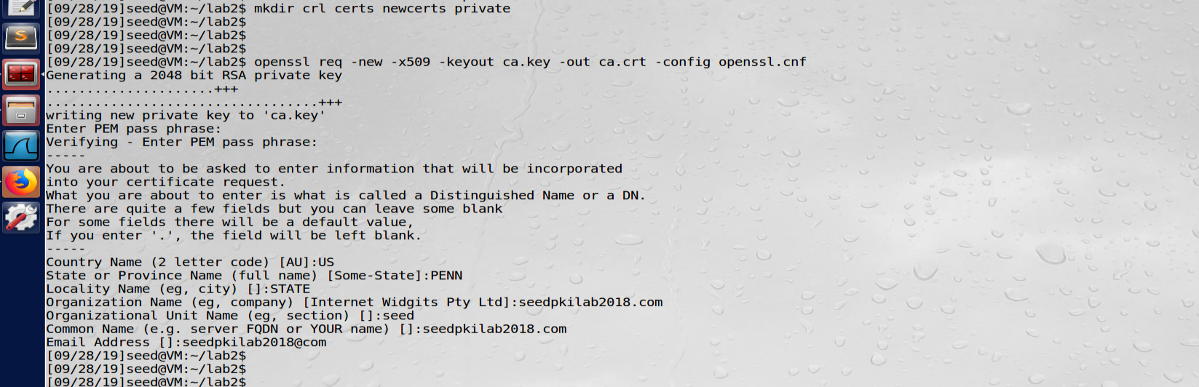

**Task 2:** create certificate of customer Seedlabs2018.com

Subtask 1: generating server key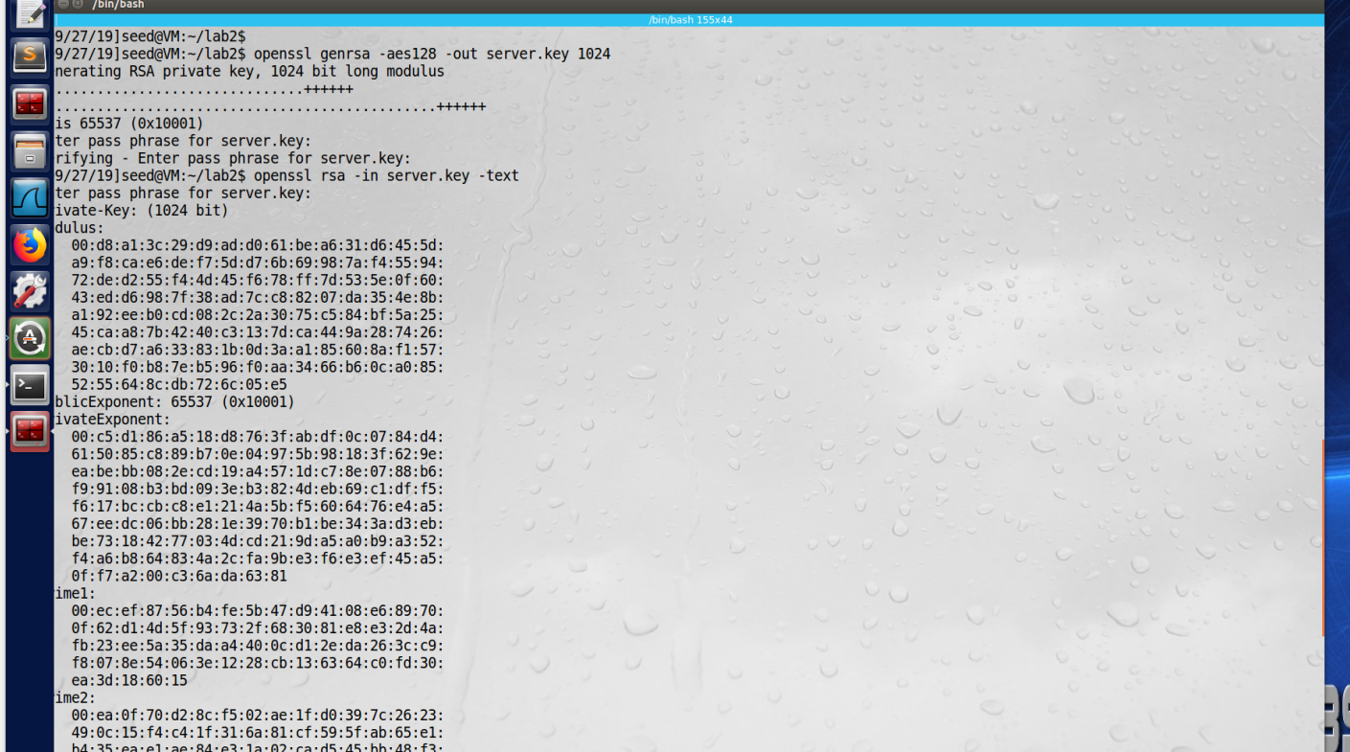

Subtask 2: give the above key for CSR to CA.

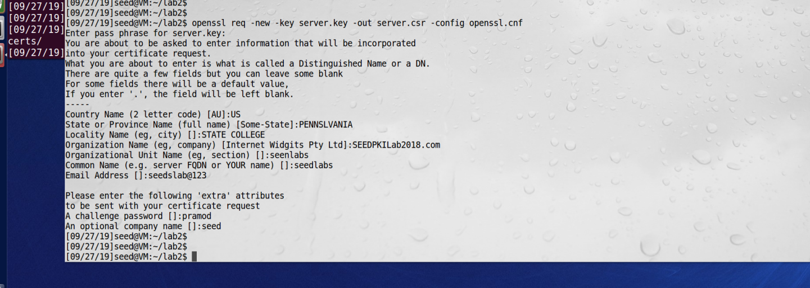

Subtask3 : CA will create certificate for seedpkilab2018.com using CSR given by customer

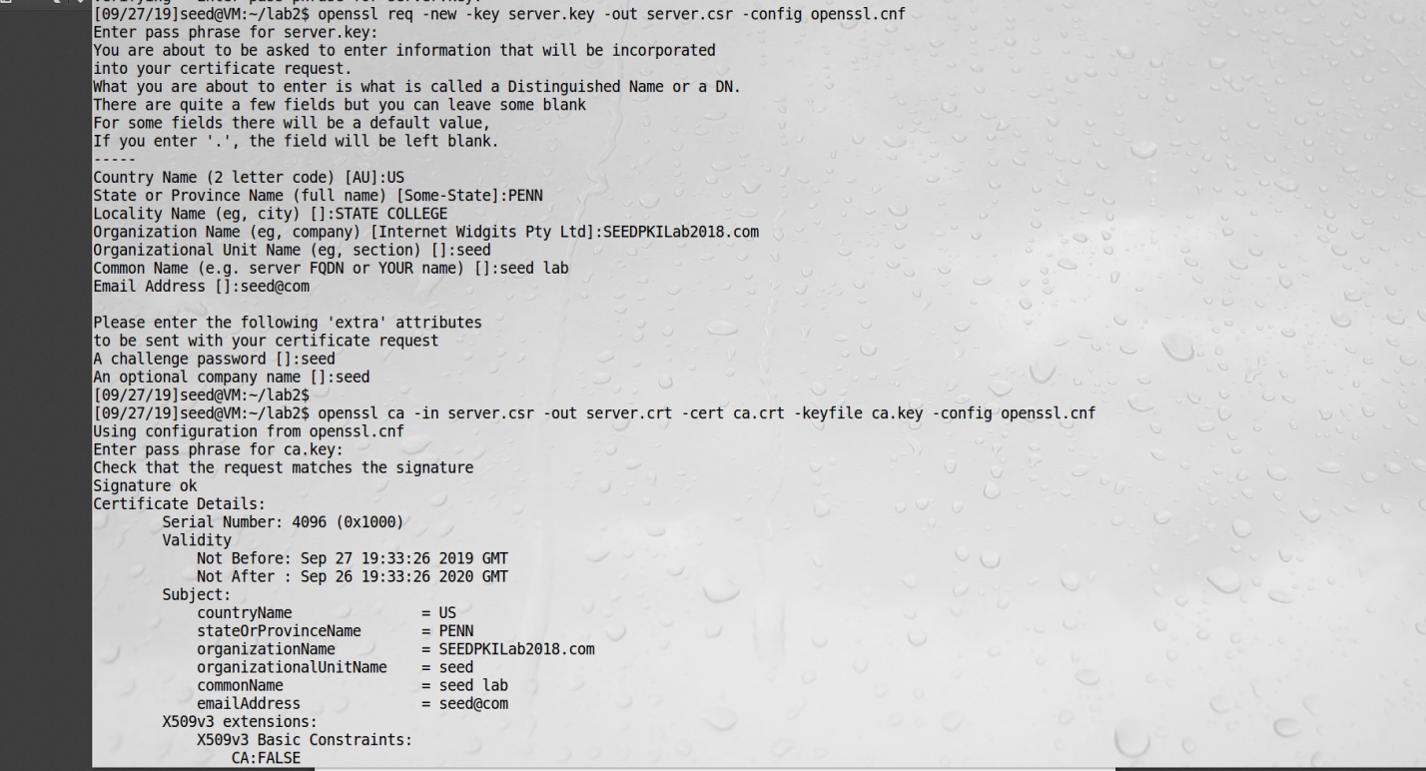

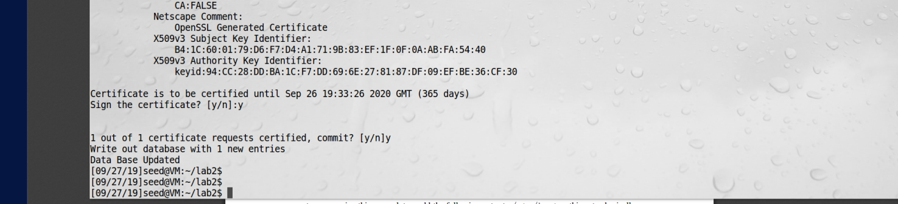

**Task 3:**

Created server.pem using server key and crtificate signed by ca crt and ca key.

Added exception in firefox for seedpkilab2018.com:4433

Here is command and screenshot of website

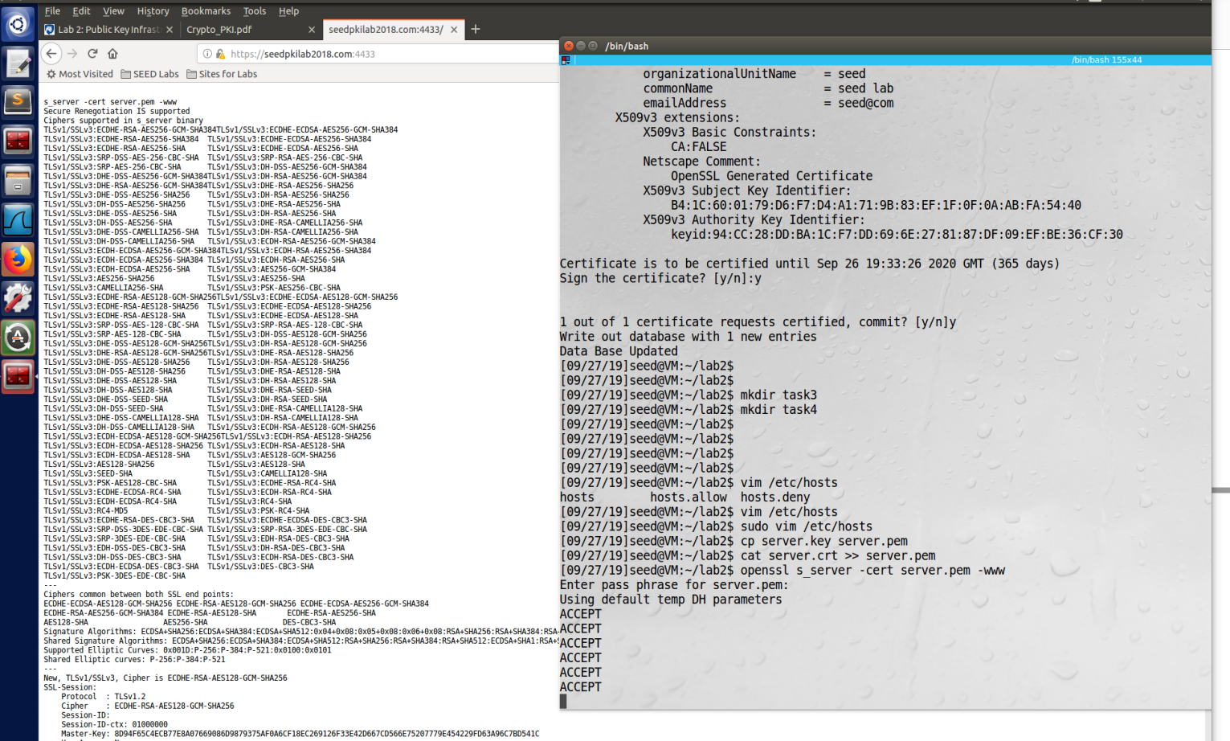

**Task3.1 Edited One byte in server.pem**

Observation: openss server started giving error and it didn’t start

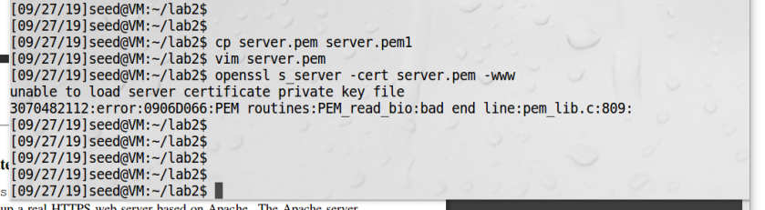

**Task 3.2 :** Try to open <https://localhost:4433>

Observation: though seedpkilab2018.com and localhost both are pointing to same ip address 127.0.0.1 but website doesn’t open for localhost because openssl server is running with seedpkilab2018 domain and it doesn’t recognize localhost domain name.

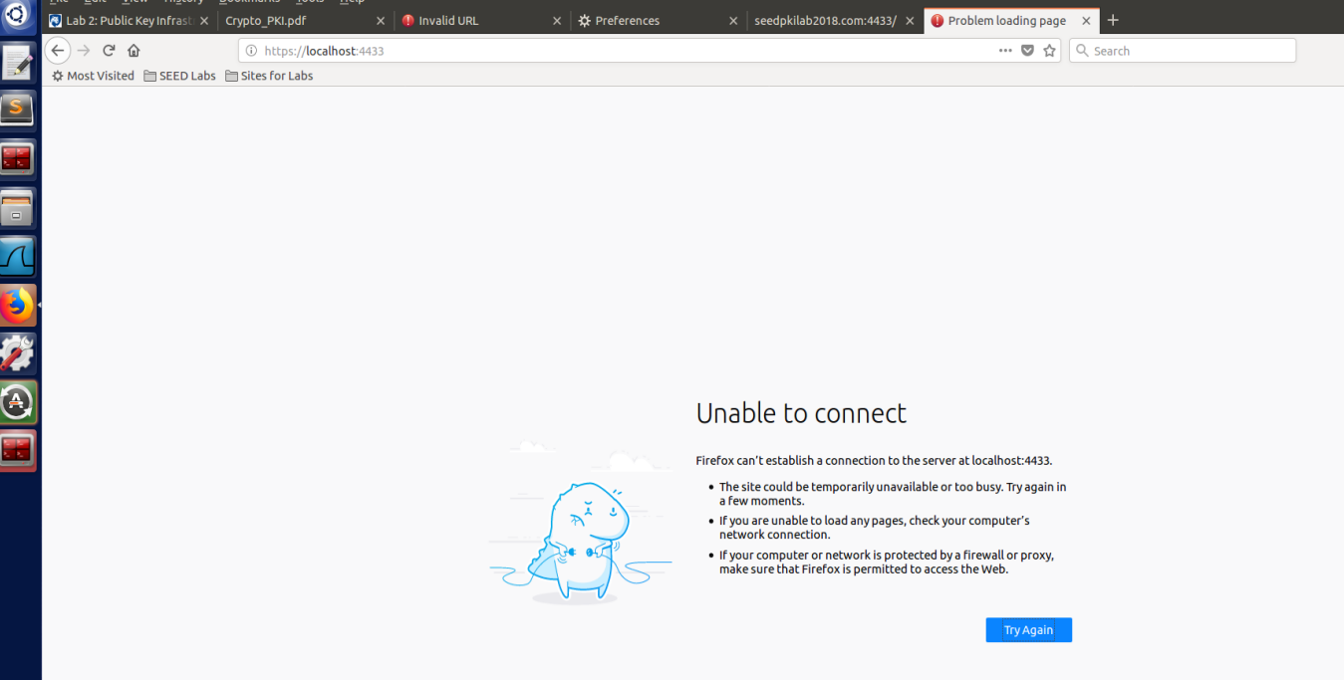

**Task 4:**

To enable our website seedpkilab2018 in apache server (along with ssl), edited both file in /etc/apache2/site-available/ directory:

Add our website in hosted website:

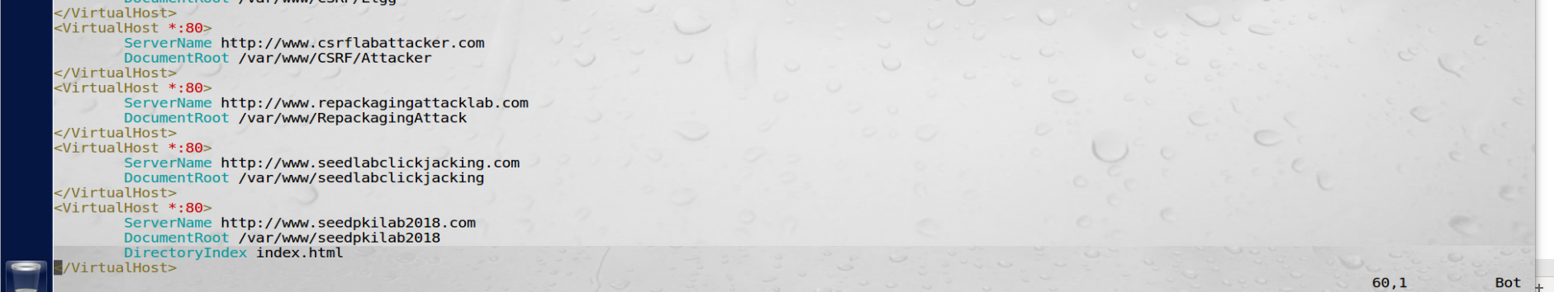

Added server key and certificate location in SSL file:

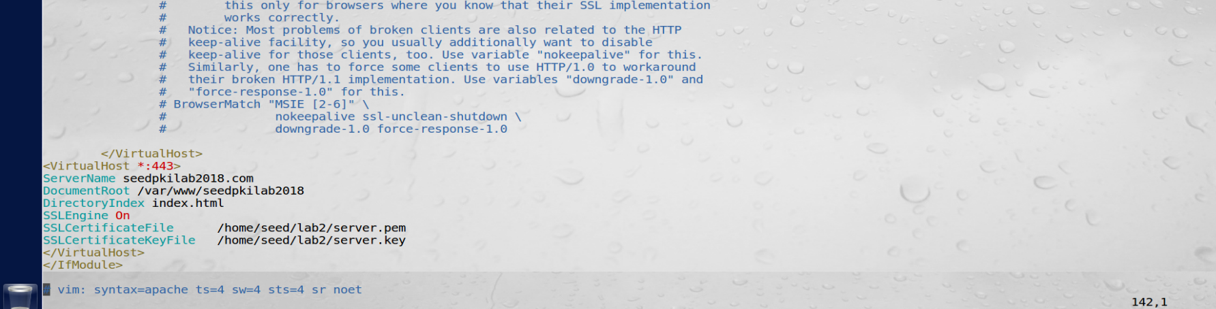

Test configuration, Enable ssl and restart the server.

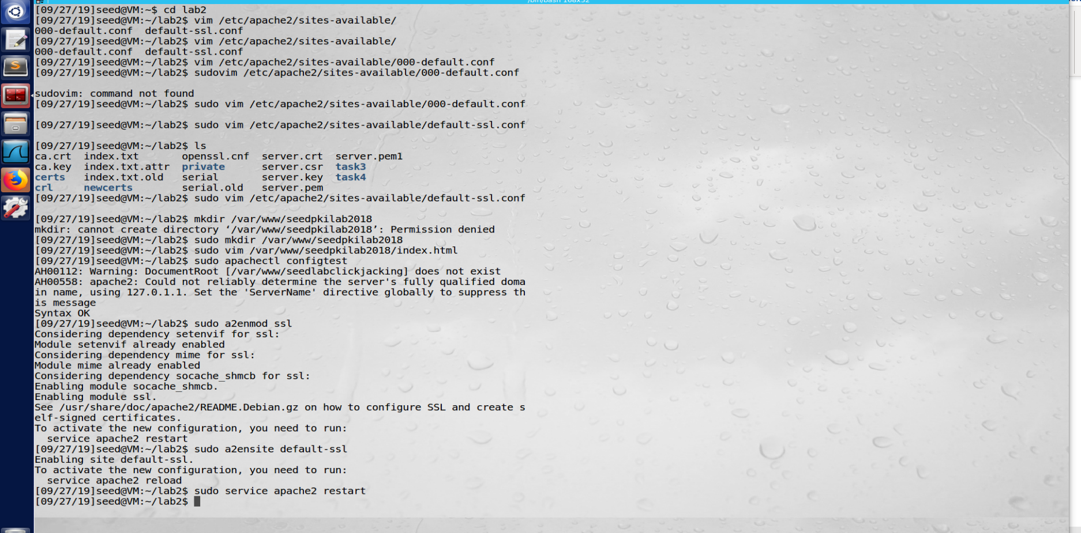

Open our new website

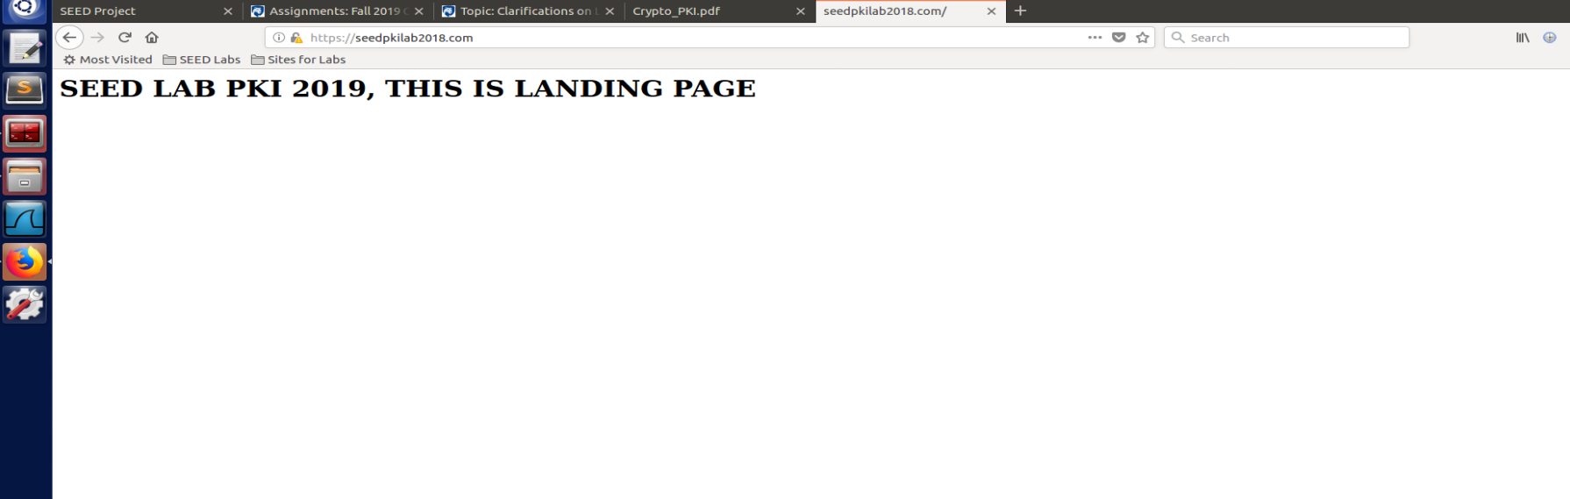

**Task5:**

In this section we will see how MIMA doesn’t work with PKI.

Let suppose attacker try to poison the DNS with its own ip address, So when user actually visit “fakebook.com” (**not facebook.com**), that server will server him a certificate. Now 2 cases can happen:

1. The presented certificate(by server) is genuine but not for “fakebook.com” may be for gmail.com, in that case user browser will detect that servername is not matching with user URL so It will report the fail certificate verification.
2. If Attacker present a forged certificate, in that case User browser wont be able to verify that certificate with preinstalled CA’s certificate in user browser. In this case too user will get the certificate failure warning.

To demonstrate this, we will use second option from above 2 option’s.

1. Create a new CA & its certificate. Create a public key for fakebook.com and host on same apache server.

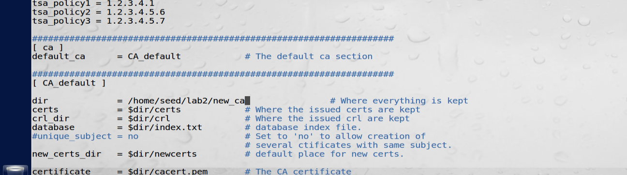

Generate key and get verified by our fake CA.

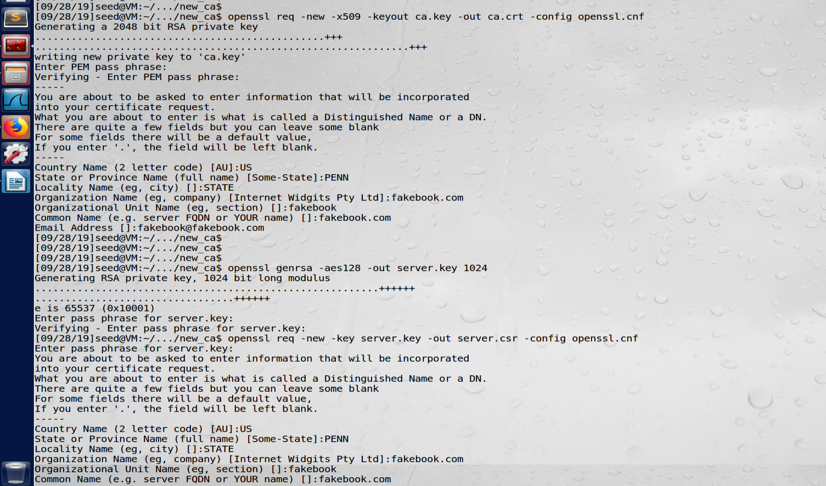

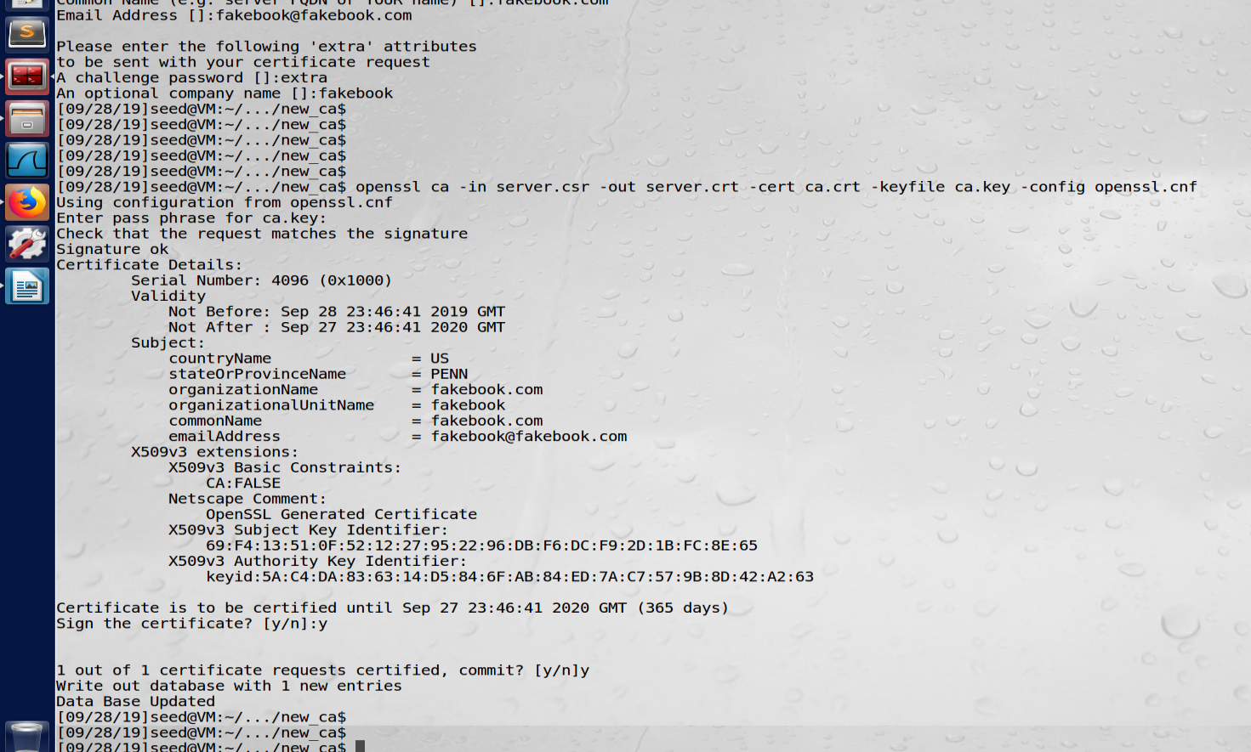

Now add this(keys and certificate) to apache server and do DNS poising:

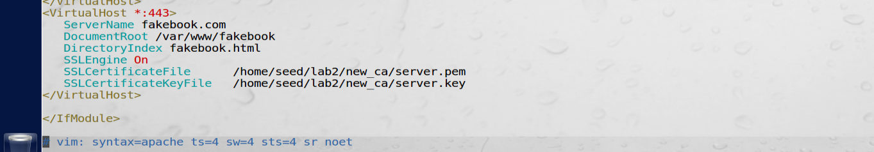

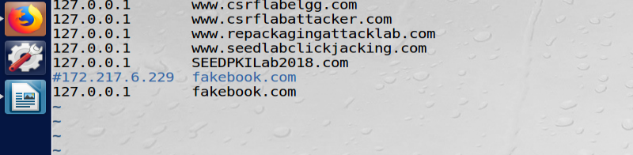

When user visit fakebook.com and we will present forged CA certificate then we can see browser is not able to verify it.

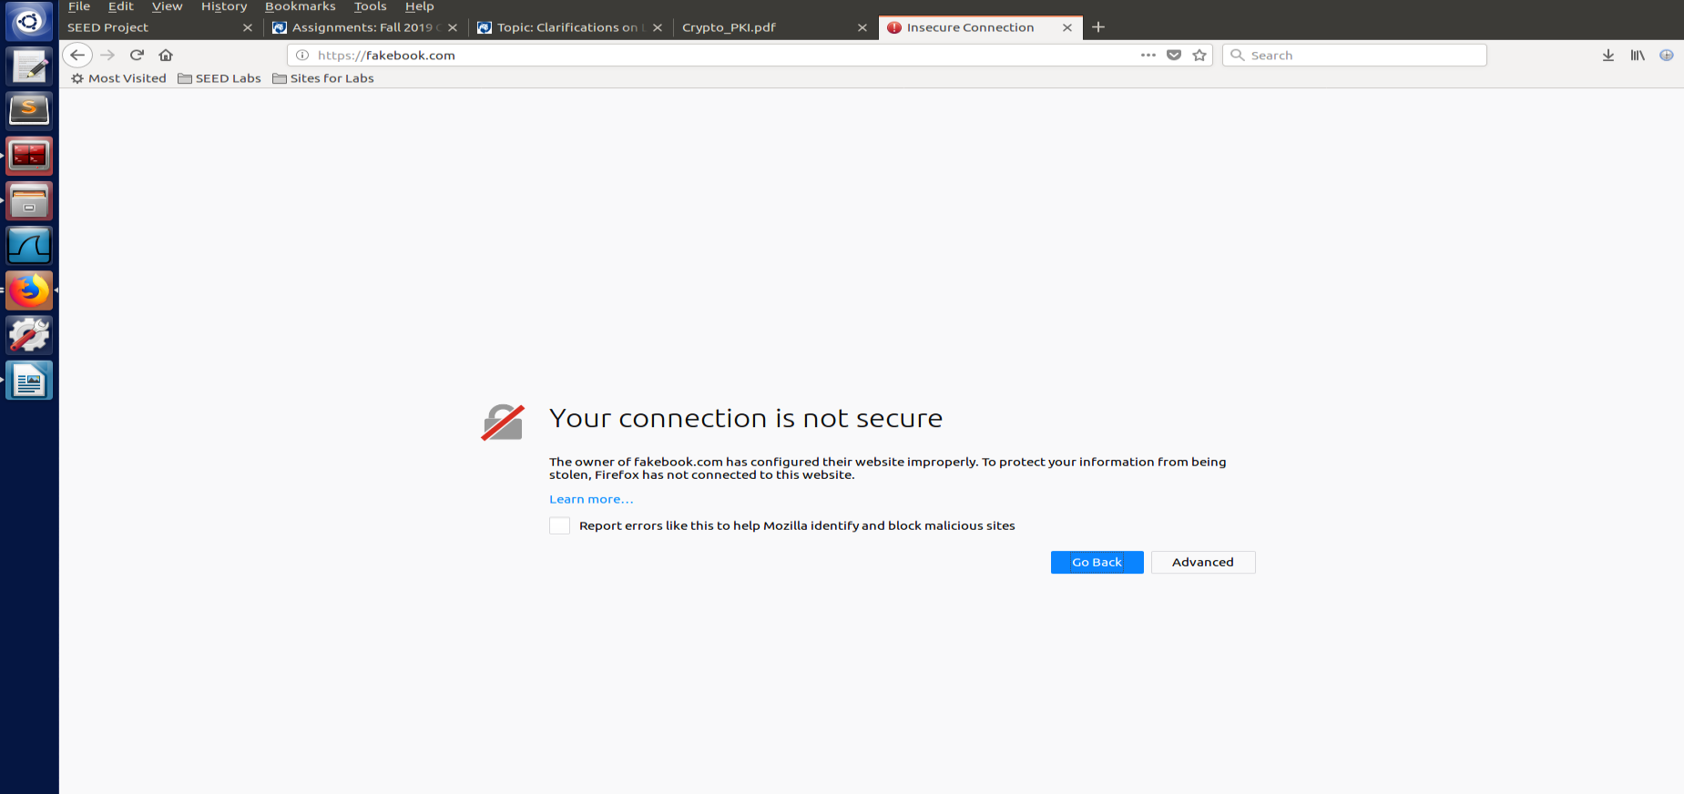

When poisoning for gmail ip address: it will also result in same as above, certification and domain name will fail the verification.

**Task 6:**

We have seen in task 5 that the certificate generated by attacker didn’t match the preinstalled CA’s certificate. In this task we will assume that CA’s private key is compromised and now attacker will be able to create certificate which can be verified in browser.

Since we can’t get versign or other CA’s private key to create certificate which can be accepted by browser, so we have to add our CA’s certificate in browser. Hence all traffic will be redirected to attacker server and he can present his key to user and decrypt the messages.

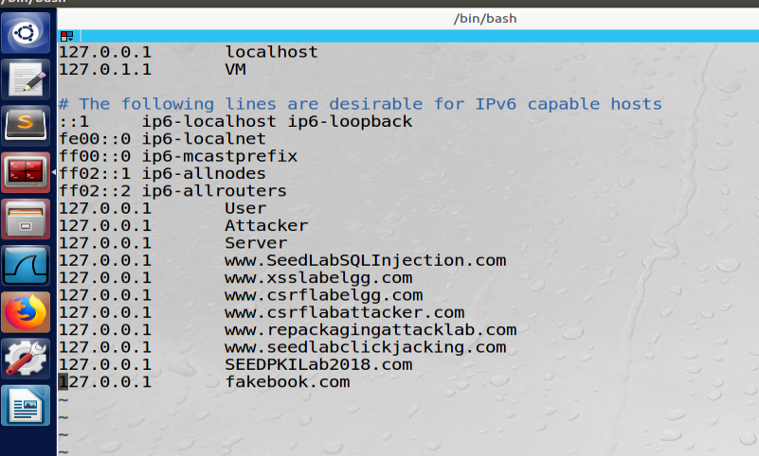

Here is Fakebook which look like facebook

